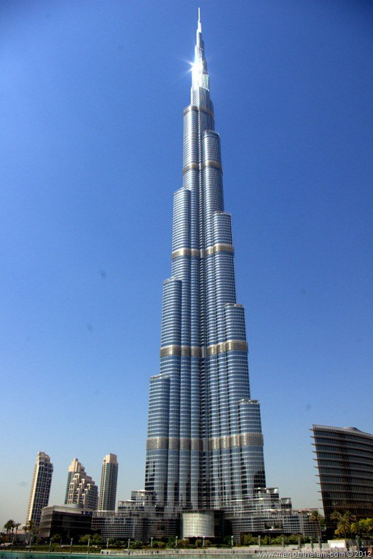
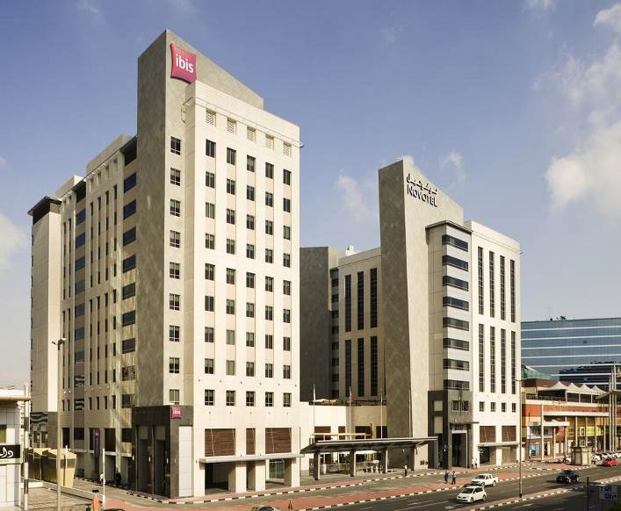
PROFILE
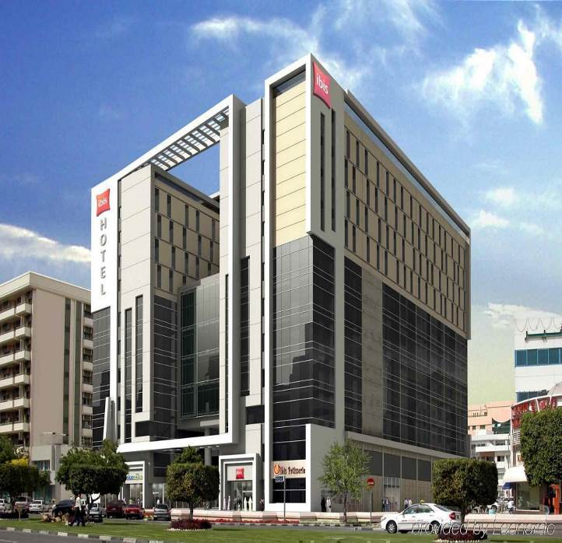
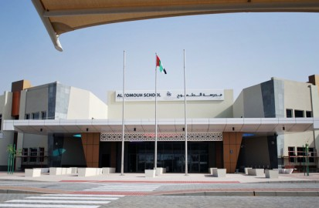
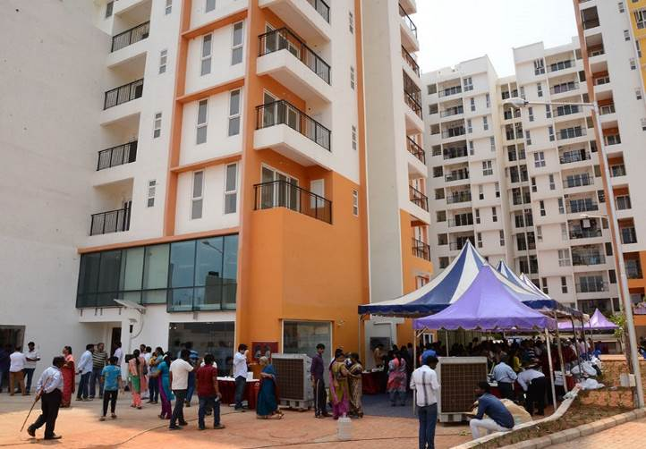
CURRICULUM VITAE
`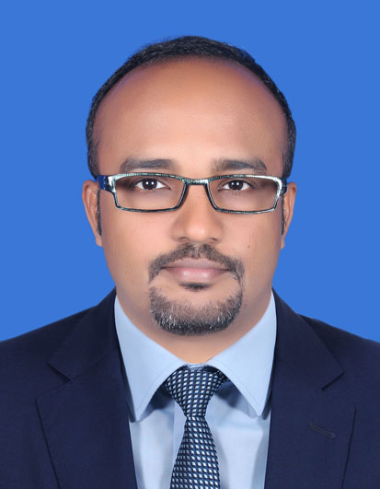

K. BALAJI
Mobile: +974 3021 6823, 3084 8874
E-mail : k_balaji777@yahoo.co.in
Doha, Qatar
_____________________________________________________________________

DESIGNATION PREFERRED : Construction Mgr. / Senior Project Engr.

CURRENT DESIGNATION : Assistant Project Manager

PROFESSIONAL SUMMARY

- Above 15 years of Experience in the field of Civil Engineering including MEP activities, Which includes Monitoring Work Progress, Controlling CPM, Materials Arrangement, Quantity / Quality Analysis, Labour Management etc.,
- International Experience in Qatar - Since April 2015 – Till Date, Working in Al Shareef Enterprises as Asst. Project Manager in following projects
Project 1:- Nuwat Residential Tower – G+2B+22 Storey’s +Lower & Upper Roof Residential Building in Lusail, Doha, Qatar - Completed
Project 2:- Fox Hills Residential Building – G+B+4 + Lower & Upper Roof Residential Buildings 4 Nos. in Lusail, Doha, Qatar - Completed
Project 3:- Al Shareef Lounge & Dining – G + 1 Storey Residential Palace type Building for His Excellency – Finance Minister - Al Khor, Qatar - Completed
Project 4:- Al Khor Residence - G + 1 Storey Palace Building for His Excellency – Finance Minister - Al Khor, Qatar – Handing over progress
- International Experience in UAE July 2005 – November 2006 the World’s Tallest Tower Project “BURJ KHALIFA” – Samsung – Besix – Arabtec – JV.
- International experience since Jan 2007 to Dec 2009 in Khansaheb Civil Engg. LLc.,
Project 1:- “Ibis and Novotel Hotel” contains 2B+G+S+ 9 floors Completed
Project 2:- “Ibis Hotel & Offices” contains 2B+G+M+9 floors Completed
- International experience since May 2010 to July 2011 in System Construct LLc.,
Project 1:- “ADNOC filling station” Abu Dhabi project Completed
Project 2:- “Abudhabi Future School Project, Mezyad” Al Ain completed

- India experience May 2000 – June 2005, Power Plant, Powder plant in Tamilnadu, and Hotel, Residential cum Commercial buildings completed etc.,
- Project in L&T is Residential Project – 2 Project completed at Chennai Since March 2012 to March 2015 which is B+Stilt+11 Storey’s & B+Stilt+4 Storey’s
- Procurements of Men, Materials & Machineries (MMM)
- Conducting inspection and getting approvals from Client/Owners for executed jobs
- Monitoring looks ahead schedule for each activity to complete on time
- Checking & Submitting Weekly and Monthly progress report to Owner/Client
- Arranging periodical meeting with the Consultants, Contractors to attain the target and to sort out their problems
- Monitoring work progress with all aspects of Quality, Cost, Time cum Safety and reporting to Higher Management
PROFESSIONAL EXPERIENCE – PRESENTLY IN QATAR (Around 3 years)

Present Company : Al Shareef Enterprises, Client
Designation : Asst. Project Manager
Period : Since April 2015 to Till Date
Project 1:- Nuwat Residential Tower – G+2B+22 Storey’s +Lower & Upper Roof
Residential Building in Lusail, Doha, Qatar - Completed
Project 2:- Fox Hills Residential Building – G+B+4 Storey’s +Lower & Upper Roof
Residential Buildings 4 Nos. in Lusail, Doha, Qatar - Completed
Project 3:- Al Shareef Lounge & Dining – G + 1 Storey’s Residential Palace
Type Building for His Excellency – Finance Minister - Al Khor, Qatar –
Completed
Project 4:- Al Khor Residence - G + 1 Storley’s Palace Building for His
Excellency – Finance Minister - Al Khor, Qatar – Handing over progress
Consultant 1 : Erga - Design Consultant.
Consultant 2 : Kernel – Design & Supervision Consultant

Role / Responsibility:
- Checking of Weekly, Monthly reports receiving from Consultants /Contractors and submitting to PM / HOD / Owner
- Monitoring Overall Progress and reporting to Head of Dept
- Finalizing Client direct suppliers, Getting Price Proposal & Preparing Comparative statement to get decision from PM / HOD
- Conducting Client Site visit for approvals, Site Meetings with Consultants, Contractors, Suppliers in present with PM / HOD /Owners
- Preparing and Submitting Consultants / Contractors / Suppliers Payment to PM / HOD
- Inspection from Client side for any specialist works like Water Proofing, Ceiling Closure, Finishing works, etc.,
- Preparing Snag, Checking of Handing over documents from Consultants / Contractors
- Material approvals / Technical verification for Civil / MEP prior submitting to Owner
- Coordinating / Follow-ups for Lusail /Kahramaa /Municipality or any Authority approvals for TBP, DC1, DC2, BP, etc.,
- Site Mockups to be carrying out and checking prior to invite Owners
- Review of drawings and clear the issues for Consultant & Contractors

PROFESSIONAL EXPERIENCE – IN UAE (More than 6 years)

Company : System Construct L.L.C., Abudhabi, UAE
Designation : Project Engineer
Period : Since May 2010 to July 2011
Project 1 : ADNOC Filling Station, Abudhabi
Project 2 : Abudhabi Future School Mezyad, Alain
Consultant 1 : Altorath Engineer & Architect Consultant
Consultant 2 : Dewan Architect and Engineers

Project 1: Construction of Petrol filling station. It contains C Store building, LPG Store, Fuel tanks installation, Service Store and Canopy.

Project 2: Construction of Abudhabi Future School Project Mezyad contains Ground and First floor with Hollow core slab and partly cast in situ. Now this Project is completed and snagging in progress prior to handing over as per consultant comments, having Swimming pool, Auditorium, Gymnasium, Cafeteria and class rooms including Landscape and Hardscape works

Company : Khansaheb Civil Engg. L.L.C., Dubai, UAE
Designation : Senior Engineer
Period : January 2007 to December 2009
Project 1 : Ibis & Novotel Hotel, Dubai, UAE.
Project 2 : Ibis Hotel & Office, Dubai, UAE.
Consultant : WS Atkins

Project 1: It contains 2B+G+Service+9 Floors + Lower & Upper roof. It contains 9 Lifts by Otis, 5 Staircase, 7 Shear wall, Adult and Children Swimming Pool, 150 Car Parks and Above 500 Rooms. Working from begin to end of project. My scope of work areas are 2Basements, Ground floor, Service floor and First floor. In those floors Complete finishes interior cum exterior works and handing over made by self. Also Kitchen Package done by TSSC sub contractor specialized in kitchen equipments fixing and commissioning overlooked by self
In this project also worked alone for few months as rebar coordinator using Steel Pac system. (Due to the absence of Senior Structural Engineer)

Project 2: It consist 2B+G+Mezannine floor+9 Floors. It contains 6 Lifts, 6 Staircase, 5 Shear wall, car parks and Hotel rooms cum offices. Work form Basement to End of project. My scope of work areas are External Elevation by EIFS system and 1 to 5 Floors complete finishes. Chasing of MEP subcontractors and Hand over made

Company : Arabtec Construction L.L.C., Dubai, UAE
Designation : Civil Supervisor
Period : July 2005 to November 2006
Project : The Burj Khalifa (World Tallest Tower), UAE.

Nature of works : Working in Tower-Slab section contains Wing A, B, C and Center core, getting approval for Formwork like Perry cum Meva system. After concrete preparation for Rebar works are coupling systems done by Universal Rebar Specialist then concreting. Two floors per week was the progress. Concrete walls are surface finish by grinding & apply primer and secondary coat of paint. In the basements levels Hollow block works are going on. Looking individually and reporting to construction manager. Since from the basement till 86th floors worked over there.

About Burj Khalifa (The world tallest tower) in Burj Dubai
CLIENT : EMMAR
DESIGN CONSULTANTS : SOM
PROJECT MANAGER : TURNER
TOTAL STOREYS : ABOVE 160 FLOORS
Architect & Record supervision
On consultant : Hyder Consulting

PROFESSIONAL EXPERIENCE – IN INDIA (Above 7 years)

Company : Larsen & Toubro Limited, Chennai, India
Designation : Asst. Manager - Civil
Period : March 2012 to March 2015
Project 1 : Olympia Grande Housing Project
Project 2 : Ragamalika Housing Project.

Nature of works : Olympia Grande Housing project contains Basement + Stilt + 11 Floors residential flats with UPVC Windows & Wood Doors, Vitrified flooring and Kitchen Semi modular, Ragamalika Housing Project contains Stilt + 4 floors residential flats with Teakwood doors & windows, Vitrified flooring & Ceramic wall tiling and Kitchen is Modular cum Semi modular types, External texture and internal emulsion paint finish, Kitchen granite platform over cudappah slab and granite threshold, Wooden French Window Partially glazed. Both projects worked as a Tower Incharge (Responsible for Structure & Finishing works) in current Project finishing work completed (Mivan Shuttering – RCC Structure) and handing over in Progress, Design & Built project cum total MEP in our scope. Monitoring the work progress by day-to-day basis to complete on time with all aspects of Quality, Cost & Safety. Our project is nominated for Quality trophy finalized among Chennai region

Company : Hatsun Agro Product Limited, Tamil Nadu, India
Designation : Jr Engineer - Civil
Period : March 2004 to March 2005
Project- 1 : Power Plant, Kanchipuram, India.
Project- 2 : Powder Plant, Salem, India.
Nature of works : Execution of Power & Powder Plant with Aluminum Doors & Windows, N type Ventilators with Powder coat and Johnson Lift. Tile Flooring with Epoxy based systems for ordinary & tiles grouting. (Tallest building in Salem District). It also includes Chimney foundations, Boiler foundations, Compressor bed foundations and some machinery foundations M15, M20 & M25 Grade of Concrete

- Company : The Gradient – Civil Engg. Consultants & Engineers
Designation : CAD Draftsman
Period : April 2003 to February 2004
Projects : Road Surveys
Nature of works : Taking of Levels, Preparing drawings through AutoCAD, Extracting and working levels through Excel. We undertake road projects in Tamilnadu and Kerala

- Company : Iswarya Constructions (P) Ltd., India
Designation : Civil Engineer
Period : May 2000 to March 2003
Projects : High Rise Commercial, Residential & Industrial Building
Constructions cum Planning, Valuation etc., in India
Nature of works : Newly construction of several Residential cum Commercial Buildings like Hotels, etc., Worked from Foundation to final finishing works with given needs and specification by the Client. Interior decoration also carried out in Plaster of Paris - False ceiling, Glazed Doors, Windows and Ventilators in Steel and Aluminum frames. Full of Cupboard, loft, decorative doors and windows along with ‘Prompt’ Lift. Building plans, Estimation & Valuations also done
ACADEMIC QUALIFICATION

- B Tech in Civil Engineering, With First Class in June 2012

TECHNICAL QUALIFICATION

- Diploma in Civil Engineering, First Class with Honors in April 2000

ADDITIONAL & COMPUTER SKILLS

- PMP Preparatory Course of Advance Project Management 40hrs. July 2016
- Diploma in System Management, Credit in April 1997, India.
- Diploma in AutoCAD 2000, First Division in July 2000.
- Hindi Prathmic with First Class
- English Typewriting with Higher First Class

LANGUAGES KNOWN

- English, Hindi, Tamil (Speak, Read & Write)

PERSONAL DETAILS

- Fathers Name : S. KANNIYAPPAN

- Date of Birth : September 18th 1980

- Nationality : Indian

- Marital Status : Married

- Passport No. : Z2000962

- Driving License : UAE, QATAR – Own Vehicle Available

- Present Address : Doha, Qatar

- Permanent Address : No.20 A/2, Desipalayam Street,
Kanchipuram – 631 501,
Tamil Nadu, India.
Home: 8754406219
Declaration

I solemnly declare that the above particulars made by me are true & correct to the
Best of my Knowledge & Belief

Civil Engineer Quote:

We shape our buildings, thereafter they shape us
- Winston Churchill

Place: Kanchipuram
Date: 07- MAR - 2018 K. BALAJI

